**Developing social interaction skills**

Social use of language is essential for children in developing and maintaining relationships with their peers and adults and in managing daily life.

It includes:

* Taking turns in a conversation with another person to give and receive messages
* Understanding when you are expected to respond, for example if someone has spoken to you or asked a question
* The ability to notice and respond to someone’s non-verbal communication, for example reacting to their body language and facial expression as well as their words
* The ability to maintain talk about the topic, change topic appropriately or interrupt politely
* The ability to talk and behave appropriately to different communication partners, for example you would speak more formally with your headteacher and less formally with your friends
* Knowing that you need to listen to the ideas of others, negotiate, compromise and try ideas out

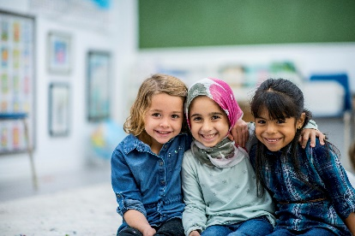**Activities and strategies to develop social interaction skills:**

Encourage the child to take turns in structured games and in conversation. Use visual aids in the classroom as prompts to use good turn-taking skills.

Activities to try:

* Shopping list. Each child has a turn to say, ‘I went to the shops, and I bought X’. As each child has a turn, they should remember the previous items to make a verbal shopping list.
* Building tower / rolling ball. For early turn taking skills, practise taking turns to roll a ball to each other or put bricks on a tower. Talk about whose turn it is – ‘my turn’ ‘your turn’.
* Pass it on. Take turns to pass an object round the group of children and describe or talk about it. Children must listen and wait their turn to ensure they do not repeat somebody else’s answer.

**Encourage use of good listening skills**

At school, children are expected to listen to a variety of instructions, and sit for long periods of time, with a large number of children. These skills are helpful for being able to listen as part of a group, instead of having instructions given one-to-one.

You can support attention and listening by:

* Always approach and address the child by name before you speak
* Get down to the child’s level whenever possible
* Use visual and multisensory prompts to engage the child’s interest, like objects and symbols
* Position the child away from possible distractions, e.g., book racks, toys
* Keep activities short. Use a timer to encourage the child to stay focussed for a set time. Stop the activity when the timer ends, even if the task is going well.
* Children learn to listen in different ways. Some children may listen better if they have a toy to fidget with or are able to move freely. Tune in to what helps your child to listen

Activities to try:

* Children get into partners and take it in turns to ask each other 3 questions, remembering to use good turn taking and listening. Each child then has to feed back to the group 3 things about their partner.
* 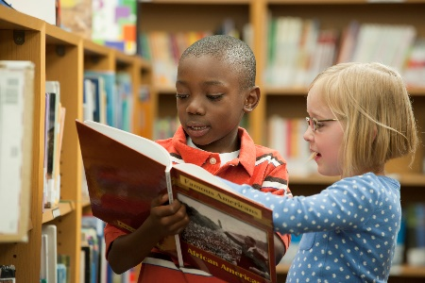Encourage children to use appropriate social skills such as saying good morning or giving a high five or wave to greet.
* If the child changes the subject or gets distracted, remind them of the subject and gently encourage them to talk about the other topic afterwards.
* Some children find it difficult to initiate play or conversation with peers and may need some support to do this. Set up opportunities where children need to work together to get a message to another teacher / complete a task / try out a new game together.