**Audiology passport**

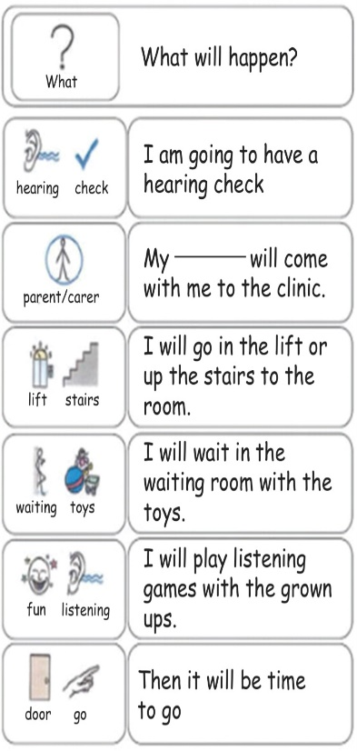

After I have done all the games I can go home!

A grown-up will look in your ears with a light.

I will listen to sounds and may see some nice animals.

One of the grown-ups will explain and show me what to do.

This is where I will be going into.

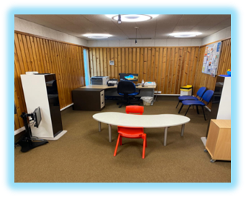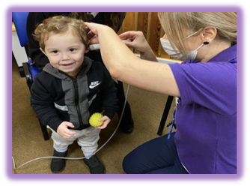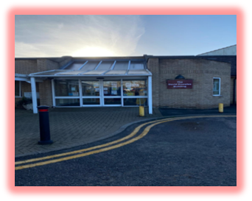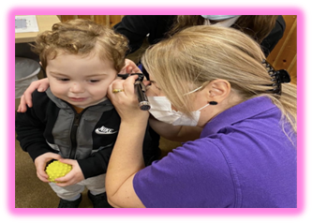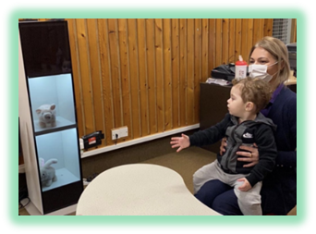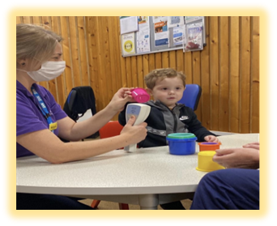

This is our room there will be two grown-ups in here and they will talk to me.